

Ref : JPSFA/AD /01/2015

Date : 18 May 2015

TO OUR VALUED PARTNERS

**Re : JPSFA 23rd Anniversary Dinner Tickets**

Johor Ports Shipping and Forwarding Association (JPSFA) will celebrate its 23rd Anniversary on the 9thOctober 2015 (Friday) at the Grand Straits Garden, Johor Bahru at 7.00 pm..

The dinner tickets are at RM100.00 each or RM1000.00 per table. There will be excellent programs prepared for the night in addition to door gifts and lucky draws.

Table allocation will be based on a ‘first pay first’ basis and therefore, we strongly encouraged you to do so to avoid disappointment. We are targeting a total of 80 tables and hope for your support and consideration to use this event as your company’s annual dinner for your staff to hype up the celebration.

We look forward to your kind support to make this major event a success. Thanking you most kindly for your participation and early confirmation.

Yours faithfully,

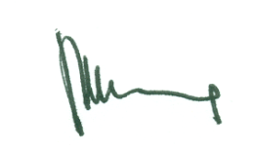

Michael Cheah

President